**A**

**PROJECT REPORT**

**ON**

**“Smart Traffic Fine Generation System”**

*In fulfilment for the award of the degree*

*Of*

**BACHELOR OF TECHNOLOGY**

**In**

**COMPUTER ENGINEERING**

**SUBMITTED BY**

Dhruvkumar Patel 15CP049 150070107015

Ketan Bhalerao 15CP050 150070107005

Monil Shah 15CP051 150070107049

**UNDER THE GUIDANCE OF**

Dr. Narendra M. Patel

Prof. Prashant B. Swadas

**BIRLA VISHVAKARMA MAHAVIDYALAYA,**

**(An Autonomous Institution)**

**Vallabh Vidyanagar, 388120, Anand, Gujarat**

**Department of Computer Engineering**

**Academic Year – 2018-19**

**Level 4**

Gujarat Technological University, Ahmedabad

**CERTIFICATE**

This is to certify that project work embodied in this report titled **“Smart Traffic Fine Generation System”** was carried out by **Dhruvkumar Patel** (15CP049), **Ketan Bhalerao** (15CP050) and **Monil Shah** (15CP051) at **BVM Engineering College (Code 007)** for fulfilment of Bachelor of Technology in **Computer Engineering** to be awarded by Gujarat Technological University. This work has been carried out under my/our guidance and supervision and it is up to my/our satisfaction.

Date:



**Dr. Narendra M. Patel Prof. Prashant B. Swadas**

**Faculty Guide Faculty Guide**

**Dr. Darshak G. Thakore**

**Head of Department**

**COMPLIANCE CERTIFICATE**

This is to certify that project work embodied in this report titled **“Smart Traffic Fine Generation System”** was carried out by **Dhruvkumar Patel (15CP049), Ketan Bhalerao (15CP050) and Monil Shah (15CP051)** at BVM Engineering College (Code 007) for fulfilment of Bachelor of Technology in **Computer Engineering** to be awarded by Gujarat Technological University. We declare that, the current report and work does not infringe upon anyone’s copyright nor violate any proprietary rights and that any ideas, techniques, quotations or any other material from the work of other people included in our report, published.

**Date:**



**Dhruvkumar Patel Ketan Bhalerao Monil Shah**

**15CP049 15CP050 15CP051**

**REPORT APPROVAL CERTIFICATE**

This is to certify that project work embodied in this report titled **“Smart Traffic Fine Generation System”** was carried out by **Dhruvkumar Patel (15CP049), Ketan Bhalerao (15CP050) and Monil Shah (15CP051)** at BVM Engineering College (Code 007) for fulfilment of Bachelor of Technology in Computer Engineering to be awarded by Gujarat Technological University.

**Date:**

**Place:**



**Examiner’s Signature:**

**DECLARATION OF ORIGINALITY**

We hereby certify that we are the sole authors of this report and that neither any part of this report nor the whole of the report has been submitted for a degree to any other University or Institution.

We certify that, to the best of our knowledge, the current report does not infringe upon anyone’s copyright nor violate any proprietary rights and that any ideas, techniques, quotations or any other material from the work of other people included in our report, published or otherwise, are fully acknowledged in accordance with the standard referencing practices.



Furthermore, to the extent that we have included copyrighted material that surpasses the boundary of fair dealing within the meaning of the Indian Copyright (Amendment) Act 2012, we certify that we have obtained a written permission from the copyright owner(s) to include such material(s) in the current report and have included copies of such copyright clearances to our appendix.

We declare that this is a true copy of report, including any final revisions, as approved by report review committee. We have checked write up of the present report using anti-plagiarism database and it is in allowable limit. Even though later on in case of any complaint pertaining of plagiarism, we are sole responsible for the same and we understand that as per UGC norms, University can even revoke Master of Engineering degree conferred to the student submitting this report.

**Date:**

**Institute code: 007**

**Dhruvkumar Patel Ketan Bhalerao Monil Shah**

15CP049 15CP050 15CP051

**ACKNOWLEDGEMENT**

We have taken efforts in this project. However, it would not have been possible without the kind support and help of many individuals and organizations. We would like to extend my sincere thanks to all of them.

We would like to thank the Department of Computer Engineering, BVM Engineering College, vallabh vidyanagar. In addition, we would like to express my gratitude towards our internal guide Dr Narendra M. Patel and Prof. Prashant B. Swadas for their constant guidance and supervision as well as for providing necessary information regarding project.

It is noteworthy that this project has given us a fantastic experience which will prove beneficial in future when we will actually work for IT firms. The overall exposure to different technologies was really worth experiencing and the project was indeed a good tunnelling path which had darkness of difficulties in its middle but also a glowing light of success at its end.

**Dhruvkumar Patel (15CP049)**

**Ketan Bhalerao (15CP050)**

**Monil Shah (15CP051)**

**ABSTRACT**

With the increase in global population, the number of vehicles on Indian roads are increasing every day. This swell has ultimately increased the load over traffic management systems. The current process of traffic control, management as well as the fine collection has faced a lot of new challenges as well as exceptions to the law on Indian roads. Moreover, it is a fact that the entire process of fine collection and memo generation is fully manual in several cities of India. This project aims to fully automate this manual process of fine generation over crossroads.

A video recorder needs to be set on cross-roads and focused over the area which is not meant to be crossed when the red light is on. Thus, the vehicles breaching this rule will be recorded. This video has to be browsed into the designed system. The system will first of all separate the video into image frames. Each image frame will be subjected to various image processing algorithms for getting the ROI, which is the number plate of the vehicle breaching the rule.

The detected number-plate would be cropped from the image and would be segmented internally by every character. Every segment containing one character of number plate will be inputted to a trained CNN for recognition into textual content.

The obtained string of number-plate would be queried to a database in order to obtain all the information about vehicle’s owner like Name, Email-Id, cell number, etc. Using the obtained information, E-memo will be sent through the system to the vehicle’s owner in form of text message as well as Email.

**KEYWORDS**

[1] Region of Interest

[2] Convolutional Neural Network

[3] Number plate detection

[4] Character segmentation

[5] Electronic Memo

[6] Fine generation

[7] Image processing

[8] Edge detection

[9] Character recognition

**LIST OF FIGURES**

3.1 Basic Flow diagram

3.2 Use case diagram

3.3 Activity diagram

3.4 Sequence diagram

3.5 Prototyping model

4.1 Slicing video into images

4.2 Sample Number plate

4.3 Proposed Method

4.4 Input RGB image

4.5 Grey scale image

4.6 Image after applying median blur

4.7 Image binarization

4.8 Image after applying closing operation

4.9 Image after applying image contouring

5.1 Character segmentation process

5.2 Sample number plate

5.3. Image binarization

5.4 Image after applying flood fill filter

5.5 Image after applying erosion

5.6 Contoured number plate

5.7 Accuracies of inception-V3 model

5.8 Accuracies obtained on VGG-16 model

5.9 Obtained accuracies for Mobile Net model

5.10 Overall average accuracy comparisons

6.1 GUI made using python tkinter

6.2 Selecting and displaying video from directory

6.3 Analysis of a video

6.4 Fine generation report

6.5 Database schema for storing vehicle owner’s details

6.6 Email memo

6.7 Screenshot from mobile where SMS arrived

**LIST OF SYMBOLS, ABBREVIATIONS & NOMENCLATURE**

CNN : Convolutional Neural Network

DIP : Digital Image Processing

ROI : Region of Interest

GPU : Graphics Processing Unit

**TABLE OF CONTENTS**

**Project Title……………………………………………………………………………………….i**

**Certificate………………………………………………………………………………………...ii**

**Compliance………………………………………………………………………………………iii**

**Report Approval………………………………………………………………………………...iv**

**Declaration of Originality……………………………………………………………………….v**

**Acknowledgement……………………………………………………………………………….vi**

**Abstract…………………………………………………………………………………………vii**

**Keywords……………………………………………………………………………………….viii**

**List of figures…………………………………..………………………………………………...ix**

**List of symbols, abbreviations & Nomenclature……………………………………………….x**

**Chapter : 1 Introduction**

1.1 Overview………………………………………………………………………………………3

1.2 Motivation……………………………………………………………………………………..4

1.3 Project's Objectives……………………………………………………………………………5

1.4 Report Structure……………………………………………………………………………….5

**Chapter : 2** **Literature Review**

2.1 Overview………………………………………………………………………………………6

2.2 Surveys and Systems…………………………………………………………………………..6

2.3 Approaches for number-plate detection……………………………………………………….7

2.4 Obtained insights……………………………………………………………………………...8

**Chapter : 3 System Analysis and Design**

3.1 Implementation Requirements………………………………………………………………...9

3.2 Design of interface…........…………………………………………………………………….9

3.2.1 Software Design………...…………………………………………………...9

3.2.2 User Design…………………………………….……………………………9

3.2.3 Communication Interface…………………………………………………..10

3.3 Software diagrams:

3.3.1: Basic Flow diagram……………………………………………………….10

3.3.2: Use-Case diagram…………………………………………………………11

3.3.3: Activity diagram…………………………………………………………..12

3.3.4: Sequence diagram…………………………………………………………13

3.4 Utilized Software Development Model……………………………………………………...14

**Chapter : 4 Inputting video and detection of number plate**

4.1 How to capture traffic video? ……………………………………………………………….15

4.2 Video slicing and image processing operations………………………………….…………..15

4.3 Detection of vehicle number plate…………………………………………………….……..16

4.3.1: Input RGB image…………………………………………………………….……18

4.3.2: Grey Scale conversion…………………………………………………………….18

4.3.3: Image Enhancement……………………………………………………………….19

4.3.4: Image Binarization………………………………………………………………...19

4.3.5: Morphological Transformation…………………………………………………....20

4.3.6: Plate Localization…………………………………………………………………20

**Chapter 5: Text recognition from the number plate**

5.1 Character segmentation………………………………………………………………………22

5.2 Utilized approach for character recognition…………………………………………………24

5.3 CNN analysis………………………………………………………………………………...24

**Chapter 6: Designing GUI and Generating E-memo**

6.1 Designing GUI……………………………………………………………………………….28

6.2 Generating memo through Email…………………………………………………………….30

6.3 Generating memo through Text message…………………………………………………....31

**Chapter-7: Conclusions**

7.1 Conclusions…………………………………………………………………………………..33

7.2 Possible improvements………………………………………………………………………33

**References……………………………………………………………………………………….34**

**CHAPTER-1**

**Introduction**

**1.1 Overview**

The traffic on Indian roads has been swelling since recent years. This has made the task of traffic management as well as the fine generation quite complex. Moreover in countries like India, the tremendous population over-crowds the roads and a lot of traffic rules are breached every day. Thus, the overall rate of accidents across cross-roads has also hiked up during the last 5 years. Due to these reasons, Indian government has passed legal rules of collecting fines from the vehicle owners who break the rules on the cross-roads as this would lower down the breaching of traffic rules by public. Thus, the fine generation system holds a core place in controlling and managing traffic over cross-roads.

However, the entire system of fine collection in several Indian cities is manual. The video on cross roads is manually recorded and then taken to the memo generation hub where all the vehicles are zoomed to obtain their number plates and then, a memo is generated after certain days. Now this reduces the efficiency of traffic management as well as control. Moreover, many of the vehicles breaching the rules are missed out and no memo is generated for them through the current system. Also, the memo which reaches after certain days creates truth issues between government and the vehicle’s owner.

This project basically aims to automate this entire fine generation system. The project dawns with a video camera focused over the cross-road area which is not meant to be crossed when the red light is on. The recorded video is to be transferred to our system where first of all the video will be sliced into image frames. Now, every image frame is subjected to a set of image processing algorithms in order to efficiently detect a bounding box over the number plate of the vehicle. After getting the number plate, the image is cropped and then binarized. Now, the number plate is internally segmented across every character.

Every individual character of number plate is cropped after segmentation and inputted to CNN model for recognition. The entire string is stored and queried to a database which holds the details of vehicles and their owners. The Email-Id and phone number of the vehicle’s owner is obtained from the database and then, electronic memo in form of Email and text message is generated through python APIs.

This is how the project automates the process of fine generation for breaching of rules over Indian cross-roads.

**1.2 Motivation**

The ground level logic concluded that an automated system is definitely required for traffic fine generation. The current process for fine generation has several defects and thus a need for advanced system arises. Moreover, manual systems are exposed to various exceptional cases like missing certain vehicles for fine, incorrect decoding of number plate, etc. Also, the fine reaches 2 to 3 days late which causes lack of trust between government and public.

Machine learning and image processing have gained a huge importance in recent years and are on a constant cycle of development. The advanced algorithms of these robust concepts are strong enough to detect objects as well as efficiently decode the text written inside an image.

Hence, there was an idea to bring together a group of these remarkable concepts, so that when we need them, they could mend the problems that traditional methods never could. The basic idea was to detect the number plate from image using image processing algorithms, crop the number plate and later input it to a CNN model for recognizing the number inside the number plate. The obtained number was to be queried with the database and all of the required details of vehicle’s owner were obtained.

Thus, several practical factors proved as good motivators for this project. The efforts were given a boost by an oath to tackle the current problems faced in the traffic fine collecting system. The final motivation was the Digital India’s initiative put forward by government in order to make India a core technology hub.

Owing to all the above motivations, the project was commenced with a positive approach and decent results were obtained.

**1.3 Project’s objectives**

This project was designed with certain pre-decided aims which gave a direction to work in appropriate direction. Every aim was subjected to a series of intensive analysis and later converted to code. Following objectives were pondered upon during the entire project:

1] To make the fine collection process fast and efficient.

2] To ease out the memo-generation process with the help of a suitable GUI.

3] To automate the fine generation process by automatic number plate detection and recognizing the text written over it.

4] To efficiently keep track of all the vehicle owners and their history in terms of being fined.

5] To take a forward step in digitizing India on cross-roads by making the fine collection process automatic, advanced and easy.

**1.4 Report Structure**

The entire report has been designed as per a structured format and has been divided into chapters. Every chapter from now discusses a part of this project and has been internally segmented into sub sections. Chapter 2 discusses the performed literature review in order to get insights about the various concepts and algorithms to be utilized to get optimal output at the end of this project. Chapter 3 focuses on the broad design of the system. Moreover, it also incorporates the required software diagrams in order to understand the overall flow and working of this project. Chapter 4 discusses the first phase of this project encompassing video slicing and image processing algorithms in order to efficiently detect all the number-plates within the images. Later the cropped number plates have been utilized for text extraction inputting them to a trained CNN which has been discussed in chapter 5. Moreover, chapter 5 also covers the analysis performed for selection of best parameters for training the CNN. Chapter 6 discusses the memo generation process through Emails and text messages by taking the obtained number from the number-plate through CNN and querying the number to the database storing information about vehicle’s owners. The obtained conclusions and improvement points of this project have been covered in chapter 7. The tail end of the report encompasses all the references which have proved helpful in order to design the entire project.

**CHAPTER-2**

**Literature Review**

**2.1 Overview**

The very first step undertaken was an intensive literature survey in order to obtain insights and a direction to work for the project. Research papers of various concepts like number-plate detection from car image, CNNs, E-memo generation, image processing, etc. were reviewed and certain insights were extracted. The literature survey concluded several things which guided the entire project and showed light at the end of confusion tunnels. Several papers mentioned certain advanced methodologies for reaching to the required state in the project and guided the overall flow of the project in a well-planned manner.

**2.2 Surveys and systems**

The past approaches involved detection of number-plate using naive algorithms of image processing which resulted in certain degree of inefficiency in case of detection. [1] has discussed the recognition of number plate using n-fold pixel splitting approach involving darkening of various pixels around the number-plate and then constructing a cropping window over it. [1] has also discussed the approach simplification via dilation of images in order to merge certain pixels of an image to get the required region of interest. [2] has explained the process of image edge detection through Canny’s algorithm in order to draw a sharp line across the borders of number-plate. [2] also stats the usage of many image processing algorithms like image binarization, thresholding, morphological transformation, etc. in order to get the entire focus over the number-plate. Thus, the earlier approaches suggested pre-processing the image containing car and its number-plate in order to get the required region of interest.

After coming across the different research related to the license number plate detection, we have found that our country has generalized the number plate properties. Earlier, there was no restriction on the number plate. People were used to place the licence plate as per their demand. As per the rules and regulations by the government people must put the number plate has certain characteristics. One important parameters we have seen from the survey regarding to the limitation of the number plate is that height of the licence plate is approximately 40 % of the width of the number plate. Moreover, image processing having the concepts of binarization, morphological operation, grey scale conversion, localization of the number plate from the survey has helped us a lot. Additionally, the significant part to get the text code of number from the cropped image of the number plate is done by the convolutional neural network. In sum, after researching the area of the core part we have used the image processing and machine learning technology to implement the primary section of the project. Furthermore, after getting the number plate in text format, we have made a connection of database through the XAMPP server for retrieving the details of the vehicle owner. This system is fully automated for third party who is not acquainted with the background processes. In addition, we have implemented the user interface in tkinter which is the most popular toolkit for GUI. Also there are other options available such as web-application, android app and so on. According to the survey, tkinter has higher reliability, compatibility compared to others. Following are the steps that we thought for implementing the whole system by distinct modules.

The smart traffic fine generation system consists of following steps:

1. Video and basic image processing.
2. Pre-processing for license plate extraction
3. Character segmentation & recognition using CNN
4. Notifying the vehicle owners via Email and SMS.

**2.3 Approaches for Number-plate detection**

YOLO- You Only Look Once is an algorithm for detecting object with a great amount of speed. An algorithm has same concept as neural network which divides the image into N x N grid for creating bounding box for the objects which appear in the images and also predicts the probabilities for every region of the image. Moreover, there are different classes in YOLO pre-trained model such as person, animal, car and so on. Unfortunately, the object number plate is not included in the different categories of classes. For that reason, we have created the dataset of different images of cars having number plate by searching on the internet. Furthermore, we have made the bounding box around the number plate in dataset which will be used to store the new weights of the number plate in the weight file. After ready with the dataset for training we have gone through the different approaches for performing the more than thousand iterations in training period. Firstly, we tried on the local machine for train a model but it took a long time and hung the computer, then we moved to the Google Cloud platform where we have used the Virtual CPU for training but it also took more time than expectation. Utilization of GPU on Google Cloud platform is slight costlier. After that we came through the AWS, where we were not able to perform the training in certain time. These platforms are not free to us. Considering the above implications in training as it requires powerful GPU, we dropped the idea of YOLO and thought about SSD, that is single shot detector but considering the more disadvantages of it, we finally move on the image processing where we succeed to detect the number plate.

**2.4 Obtained Insights**

Image Processing focuses on developing a computer system that is ready to perform processing on a picture. The input of that system could be a digital image and also the system process that image using efficient algorithms, and provides an appropriate desired output. The goal of image processing is to speed up or compress image/video information for further implementation process. Moreover, tkinter follows the layered approach. As a result of this, it is inherited from the advantages of GUI toolkit that had desired time for mature. Also, it hides the complex and detailed calls and functions which makes it painless to go with tkinter. Furthermore, connection to the database is very flexible in python compared to Java. Portability is major advantage of tkinter over most other libraries which make user to restrict from one to two platforms. Additionally, it gives native look and feel for particular platform where the program runs on.

**CHAPTER-3**

**System Analysis and Design**

**3.1 Implementation Requirements:**

All the modules of this project require certain software support and preparation of dataset required some basic hardware too. Following are the required software tools which were used for project’s implementation:

1. **Python 3:** This is an open source programming language with certain powerful librariesfor designing neural networks and performing image processing.
2. **Image processing libraries:** OpenCV for performing required actions for image pre-processing.
3. **Neural Network libraries:** Keras and Tensorflow for implementing and training the CNNmodel.
4. **Tkinter GUI libraries:** This mainly is used to provide interface between admin and backend system.

**3.2 Design of Interface:**

**3.2.1 Software Design:**

The entire design of the software is implemented in Python language with the help of required packages such as cv2, tkinter and so on.

**3.2.2 User Design:**

In this system, administrator will be provided by the input window where he has to browse the video captured from the camera which requires to find the vehicle-owners who have broken the rules. After video processing, the list of the number-plate is generated on the window. Moreover, one report will be generated too having the details of vehicle-owner and a button will be there to send the SMS and email to the owner of the vehicle. The entire user interface has been implemented in tkinter GUI toolkit in python.

**3.2.3. Communication Design:**

The system is also connected to the database having the details of the vehicle-owner. We have used XAMPP server to communication purpose with the front-end system. The database has the normalized tables with appropriate details of people.

**3.3 Software Diagrams**

**3.3.1. Basic Flow Diagram**

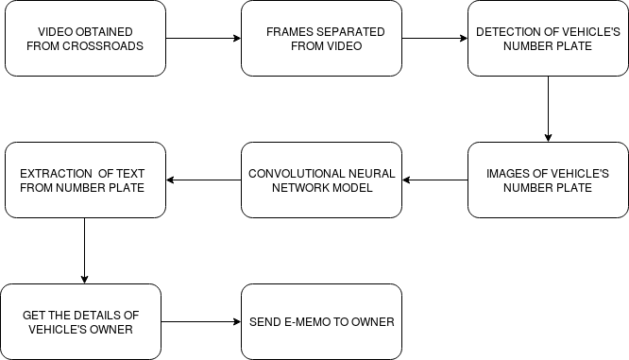

Fig 3.1 Basic Flow Diagram

This above diagram gives a basic idea about the work flow of the entire system. To start with the getting the video of crossroads is the initial phase of the system. This is a collective term for depicting the dynamic relationship in an individual system. Hence, it is used to make structure and complex diagram. Moreover, this system performs the distinct and required steps to achieve the desired results with help of image processing and machine learning concepts. In addition, number plate in text format will be resulted and the details of the vehicle owners who have broken the rules will be retrieved from the normalized database. Also, Email and SMS will be sent to the owner. In sum, this diagram portrays the overview of system which will be done by different steps

**3.3.2 Use-case Diagram**

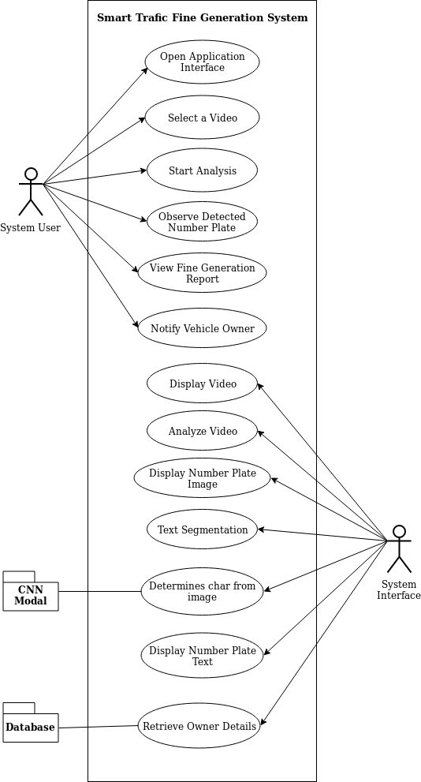

Fig. 3.2 Use-case Diagram

Use case diagrams are required to accumulate the needs for a system having an internal and external impact. These requirements are almost used for designing therefore when a system is fully examined to collect its functionalities, use cases are made and actors are determined.

Following are the purposes of Use case diagram:

* It is used to collect the requirements of any particular system.
* Furthermore, these diagrams are used to give an external overview of a system.
* In addition, this helps to recognize the outside and inside features which influence to application.
* It shows the association among the necessity are actors.

Use case diagram is drawn above of the traffic fine generation system.

**3.3.3 Activity Diagram**

Activity diagrams to illustrate the flow of control in a system and refer to the steps involved in the execution of a use case. It is also known as behavioural diagram. An activity diagram gives information about the control flow from an initial point to endpoint describing the different decision paths that are available while the activity is being processed

These are the reasons why we need to use activity diagram:-

* it illustrates the different steps which are involved in a UML use case diagram
* Model software components such as functions, methods, and operations.
* We can use this diagram to describe simultaneous activities very easily.
* It represents the restrictions, conditions and logical way of algorithms.

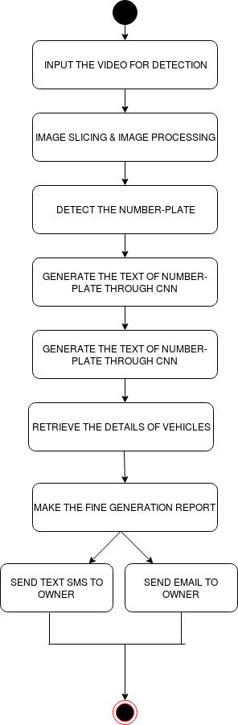

Fig. 3.3 Activity Diagram

**3.3.4 Sequence Diagram**

Sequence Diagrams follows these two steps:

* Connection which takes place in a cooperation that either discern a use case or an operation.
* High-level associations between consumer of the system and the system itself, between the application and other applications, or between co-systems.

Application of Sequence diagram:

* It is used to imagine and model the logical representation behind an advanced function, operation or mechanism.
* These are also utilized to depict details of use case diagrams.
* Moreover, it is helpful to understand the comprehensive functionality of ongoing or future systems.

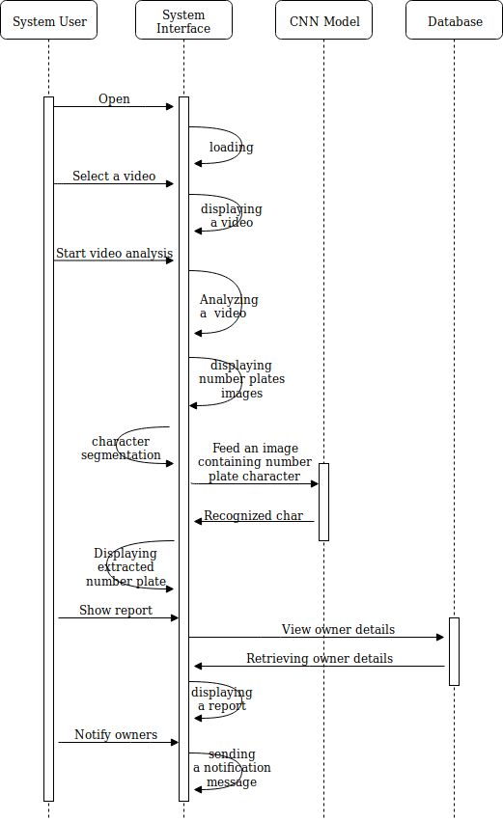

Fig. 3.4 Sequence Diagram

**3.4 Utilized Software Development Model:**

A number of software development models are available to be followed of which the Prototyping model was chosen for implementation and designing. The basic concept behind is that instead of pending the requirements before a design or coding can proceed, a throwaway prototype is constructed to analyze the requirements. This prototype is based on current need and requirements. By taking this prototype, the client will affect the actual realization of the system, since the communications with the prototype can enable the client to enhance and understand the requirements of the desired system. The prototype is not generally complete applications and systems and many of the details are not constructed in the prototype. The goal is to achieve a system with every functionality. Figure 3.5 shows different phases in prototyping model.

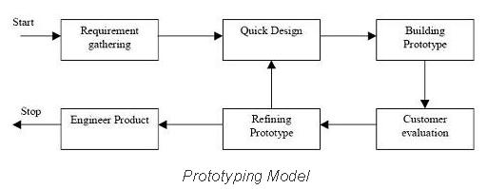

Fig 3.5 Prototyping model

**Advantages of Prototype Model**

* Users are actively participated in the development phase.
* Since this proposed method of a working model of the system is basically provided, the customers get a better understanding and planning of the system which is being developed.
* Mistakes can be detected much earlier.
* Quickly user feedback is readily available leading to better solutions.
* Missing parameters and functionality can be identified very easily.
* Confusing functions can be identified.

**CHAPTER-4**

**Inputting video and detection of Number-plate**

**4.1 How to capture the traffic video**

Here we assume that videos are captured from the high quality cameras placed at crossroads on the top of the signal lights. Make sure that the vehicle number must be recognized the clear image of the number plates. It may possible that getting the blurred image of number from video. That’s the reason we have to use the high quality cameras. Right now, we have captured the video from our cellular phone. After giving the IP address to the network camera, traffic control system administrator can access the captured videos.

There are several advantages of using the High Definition Cameras over other low quality cameras.

* Provide the maximum security for high risk establishment.
* Can zoom images without depriving focus.
* Perspicuous, detailed and pictures.

**4.2. Video Slicing and Image processing operations**

Mathematically, an image is a matrix of pixel values which is stored in computer’s memory. A raw image when directly passed for recognition can lead to inefficient results which was concluded from the literature survey. We are capturing video for some constant time and separating it into some frames and those frames are stored in the folder of machine. The frames are separated at constant interval so that same image can’t be repeated. The separation interval is determined by the user. Here, we separated the frames after every 250 ms. Below figure 4.1 shows the images which have been generated from the video.

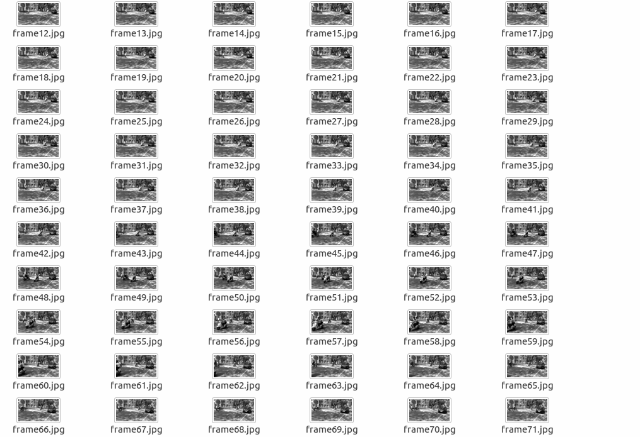

Fig 4.1 slicing video into images

**Why to store the grey scale images instead of RGB image?**

When we are storing the RGB images in the folders, the requirements of the memory will be high because RGB images require more space than the simple grey-scale image.so that if we try to convert the RGB image into the Grey-scale image then the use of memory can be reduced and object detection algorithm can be easily applied. Also there are many advantages of grayscale image over RGB image. So before storing the frames in the folder we must convert each frame to the Grey-scale.

**4.3 Detection of vehicle number plate**

The number plate detection is a part of digital image processing. In India, the number plates have fixed dimensions for the commercial and non-commercial vehicles as approved by the government.

The number plate with white background and black foreground is used for private vehicles and for commercial vehicles, the number plate has yellow background and black foreground. Below figure 4.2 shows the sample number plate with some common properties.

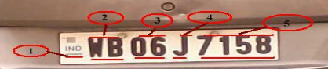

Fig 4.2 sample number plate

The red circles indicate following in figure 4.2.

1- Country code, 2- the state code, 3-the district code, 4- vehicle type, 5- registration number

Locating the number plate from the image is quite complex work in the field of image processing. The task of number plate detection is interesting because of images with varying light intensities and noise. The failure in detection of number plates in real-world application is due to varieties of number plate and some environmental factors like snow, night, rain, etc. The use of appropriate image processing techniques is most recommended to minimize above limitations.

**Proposed Method**

The process of getting ROI (i.e. number plate) from the image is divided into several parts. It is listed below:

1. Input RGB image
2. Grey scale conversion
3. Image Enhancement
4. Image Binarization
5. Morphological Transformation
6. Plate Localization

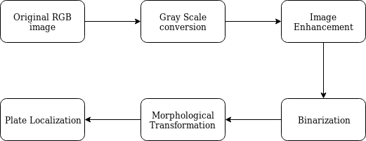

Fig 4.3 Proposed method

**4.3.1 Input RGB image**

The sample image for number plate detection is shown below:

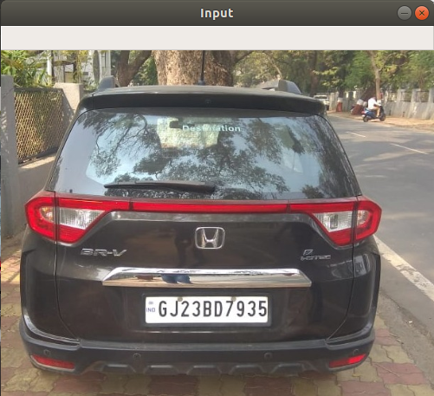

Fig 4.4 Input RGB image

**4.3.2 Grey Scale conversion**

The input image is converted to grey scale image and it is shown in below figure 4.5:

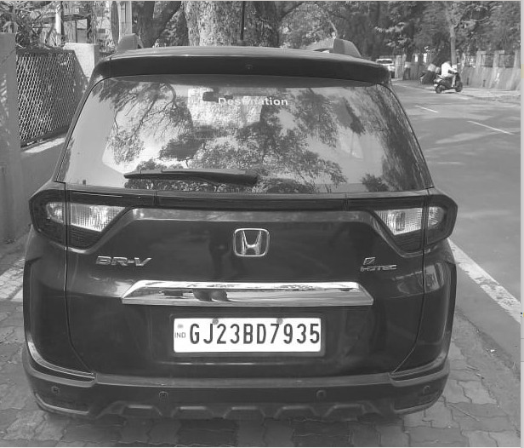

Fig 4.5 Grey-scale image

**4.3.3 Image Enhancement**

We have used median blur filter to remove noise from the image.

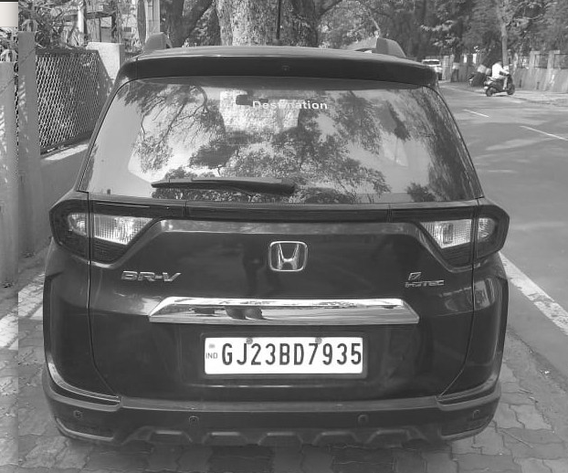

Fig 4.6 Image after applying median blur

After removing noise from the image, histogram equalization can be used to enhance contrast of the image.

**4.3.4 Image Binarization**

The enhanced image is converted into binary form using image thresholding technique.

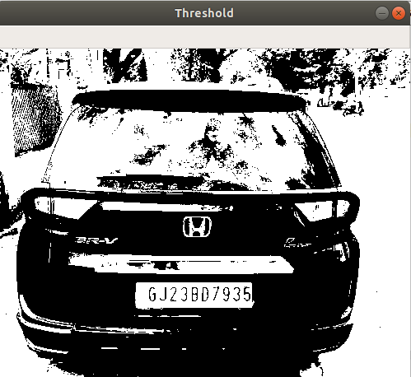

Fig 4.7 Image binarization

**4.3.5 Morphological Transformation**

The primary requirement to detect number plate is to detect plate size. The number plate is rectangular in shape. Hence, we have to identify the edges of the number plate. So, the aim is to remove unnecessary white pixels and to get clear white rectangular region where number plate is located in an image.

The morphological transformations are applied on the binary image to change shape of objects. Here, we have used closing operation, which is dilation followed by an erosion. The dilation increases the size of white pixels and erosion is just opposite of dilation.

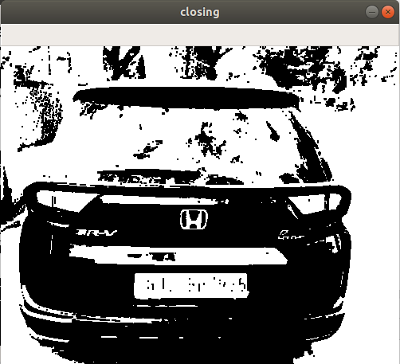

Fig 4.8 Image after applying closing operation

**4.3.6 Plate localization**

The morphological transformation (i.e. closing operation) makes enclosed regions on the image. Now, image contouring technique is applied to make bounding box around the enclosed regions. It also makes bounding boxes around enclosed regions which are unnecessary (not number plate).

Some basic properties of number plate is used here to discard those unnecessary regions. It is listed below:

1. The width is greater than height (more than double).
2. The width of number plate varies between 10% to 30% of total image width.
3. The height of number plate varies between 5% to 15% of total image height.
4. The number of white pixels are more in the region containing number plate.

After applying above properties along with image contouring, we got the region where number plate is located (figure 4.9).

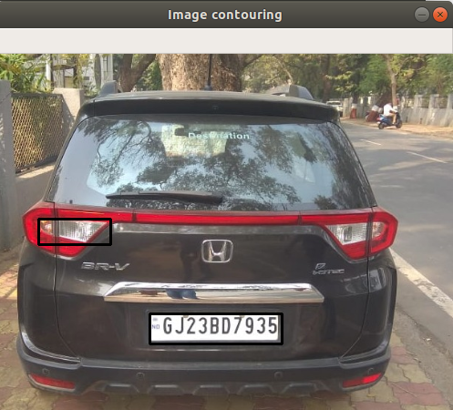

Fig 4.9 Image after applying image contouring

The image is cropped based on bounding box points and saved for the further processing on detected number plate.

**CHAPTER-5**

**Text recognition from number-plate**

**5.1 Character segmentation**

The number-plates cropped from the last phase of previous chapter was stored in a folder for further internal processing. The CNN model expected a character image rather than an entire word. Hence, every number-plate stored in the folder was subjected to internal segmentation with respect to every character of number-plate. The contouring algorithm was utilized for accomplishing this task which detects the change in pixels and crops out the required region encompassing a single character. The character segmentation process is shown in figure 5.1.

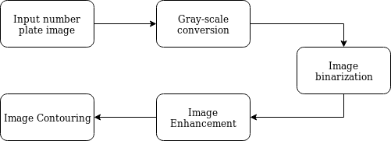

Fig 5.1 Character segmentation process

Figure 5.2 shows the sample number plate image on which character segmentation is performed. The input image is converted into grayscale to make image suitable for image binarization (figure 5.3).

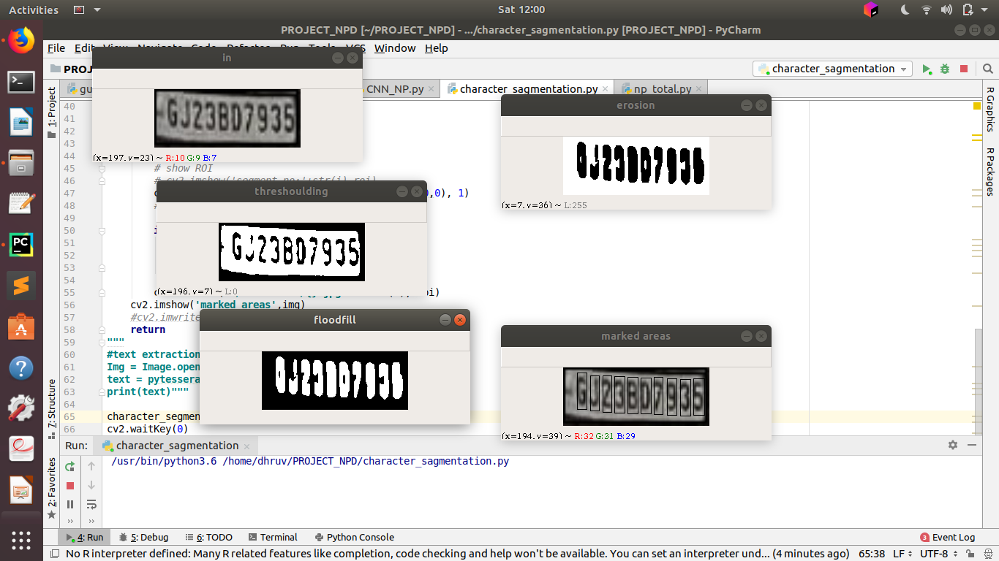 

Fig 5.2 Sample Number-plate Fig 5.3 Image binarization

After binarizing an image, Image enhancement techniques are applied to separate each characters from the number plate. Here, we are using flood fill algorithm to remove background noise (black pixels forming border in figure 5.3).The resultant image after applying flood fill filter is shown in figure 5.4.

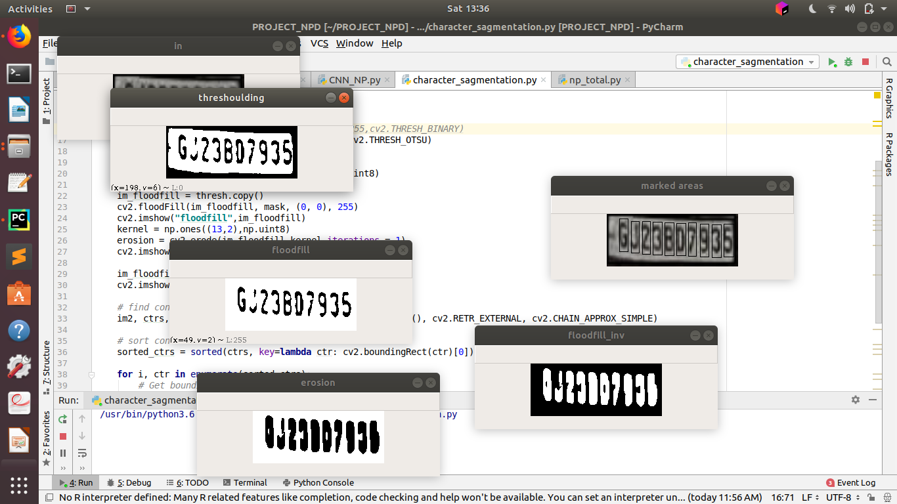 

Fig 5.4 Image after applying flood fill filter Fig 5.5 Image after applying erosion

Image contouring process makes bounding boxes around each enclosed regions. The character must form enclosed region so that it is correctly bounded. Image erosion is applied to achieve this goal. It decreases the size of white pixels based on its width and height. Here, we have applied image erosion in direction of height so that black pixels overlap each other vertically and make clear and separated black regions (figure 5.5). Now, image contouring is applied on image shown in figure 5.5 so that characters are bounded easily (figure 5.6).



Fig 5.6 Contoured number plate

As shown in Fig 5.6, the characters to be individually inputted to CNN model were contoured and later cropped off into separate images. The clarity of every character highly relies upon the obtained number-plate image. Certain images of characters appeared blur and very challenging for CNN in order to get correctly classified. However, utmost care was taken in order to remove blur and inconsistency from the images and thus, the characters were efficiently segmented out from the number-plate image.

**5.2 Utilized approach for character segmentation**

Several machine learning algorithms are under a constant research and many of them are efficient enough for text recognition from images. These algorithms have proved well suitable for appropriate extraction of textual content from the content printed in images. At global level, neural networks have been best suited algorithms for such applications.

Moreover, recent developments in the field of deep learning have given rise to a more efficient and flexible algorithm named Convolutional Neural Network (CNN) [7]. CNNs are one of the most utilized algorithms for text extraction from images [7]. Various applications have been designed using CNN in the recent years, and the algorithm has terminated with correct results for majority cases [7].

An important feature of CNN is its ability to detect simple as well as complex features of object encompassed within an image [7]. With every convolution, the text recognition algorithm keeps on becoming robust and resistant to noise in the images [9]. Moreover, the consumed memory gradually reduces with every pool operation and ReLU introduces the required non-linearity in the features [7]. Owing to all the above reasons, CNN was chosen as the text recognition algorithm and was trained for recognition of 36 classes (0 to 9 and A-Z). Thus, every segmented character was iteratively given as an input to CNN model in order to obtain the entire string of number-plate’s characters.

**5.3 CNN analysis**

The CNN model’s features were applied on trial and test basis and the overall accuracy varied by tweaking each of its internal parameters. Different flavours of CNN were worked upon and every approach provided a certain difference in terms of accuracy of recognition.

Moreover, the strides, kernel size, number of kernels, number of layers, input image size and neurons were tweaked and a comparative analysis was performed. Also, transfer learning was utilized for training the CNN appropriately, and the accuracy comparison was performed between self-trained CNN model and CNN model obtained through transfer learning.

Following results were obtained after training CNN over various transfer learning models:

**[A] Inception-V3 model (X-axis: Input image dimensions Y-axis: Observed accuracies)**

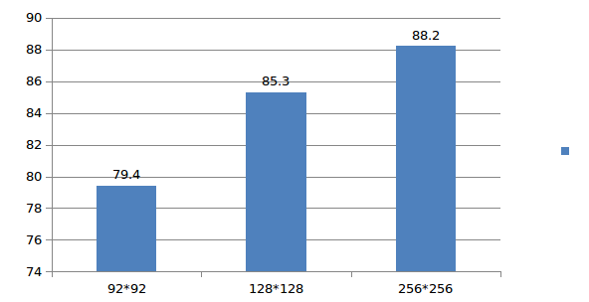

Fig. 5.7 Accuracies of Inception-V3 model

**[B] VGG-16 model (X-axis: Input image dimensions Y-axis: Observed accuracies)**

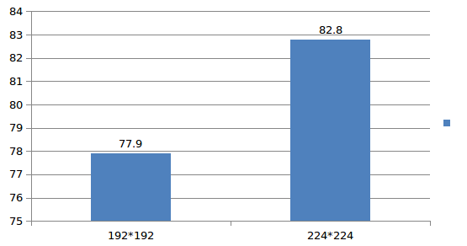

Fig. 5.8 Accuracies obtained on VGG-16 model

**[C] MobileNet model (X-axis: Input image dimensions Y-axis: Observed accuracies)**

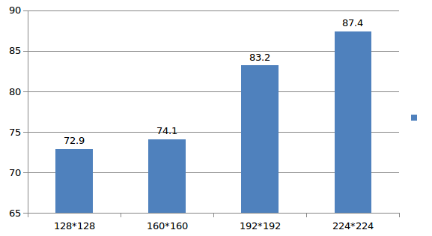

Fig. 5.9 Obtained accuracies for MobileNet model

Thus, it was observed that none of the transfer learning models were able to pull the accuracy of recognition beyond 90%. As a result, it was decided to train the CNN model from scratch by using MNIST dataset 15,00,000 images for training the CNN.

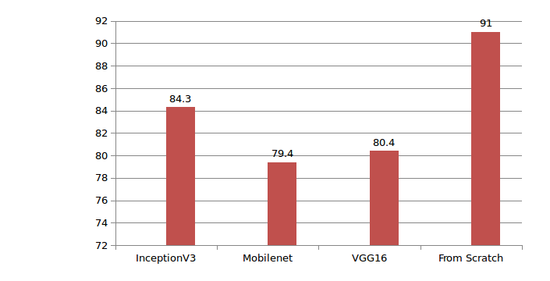

Fig. 5.10 Overall average accuracy comparisons

Following were the properties of final model which was utilized for character recognition:

[1] Initial accuracy: 91%

[2] Increased Neural Network’s body

[3] Used Leaky ReLU instead of ReLU

[4] Decreased learning rate to 1e-4

[5] Resulting Accuracy: 97.6%

Thus, CNN was inputted with sequence of segmented characters and outputted a string containing the extracted number from the number-plate. The output of the CNN was delivered to the GUI utilized for the operation of the entire application.

**CHAPTER-6**

**Designing GUI and Generating E-memo**

**6.1 Designing GUI:**

We have used python tkinter library to make graphical user interface in which user can interact easily. Some of the screenshots are shown below. Figure 6.1 shows the simple GUI which contains different blocks to display output during fine generation process.

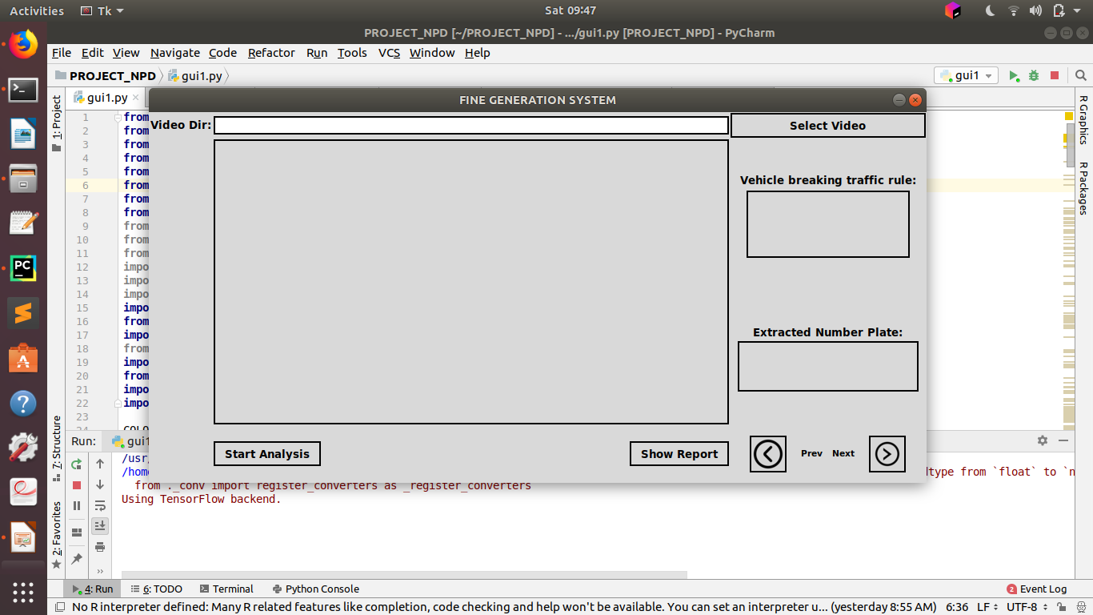

Fig. 6.1 GUI made using python tkinter

Figure 6.2 shows the process of selecting and displaying video from specified directory. “Select Video” button is used to select video from directory. The system will display the video after selecting it.

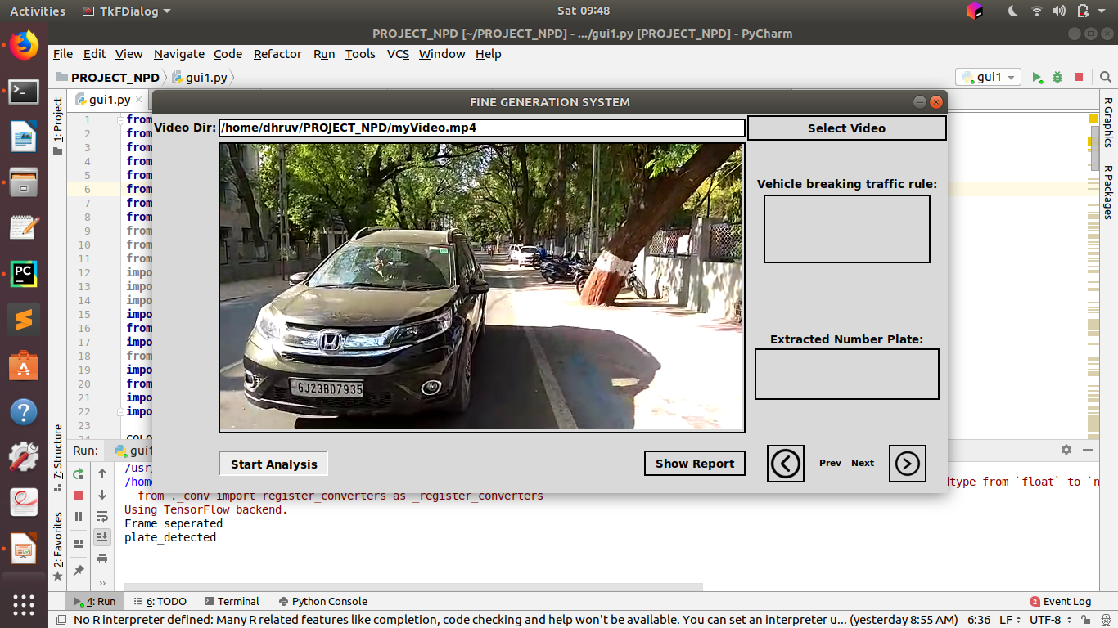

Fig. 6.2 Selecting and displaying video from directory

System user can start analysing a video by pressing “Start Analysis” button. It takes some time to analyze. After completion, the system shows the detected number plate with extracted text from it. The previous and next button are used for navigating if video contains more than one number plate (figure 6.3).

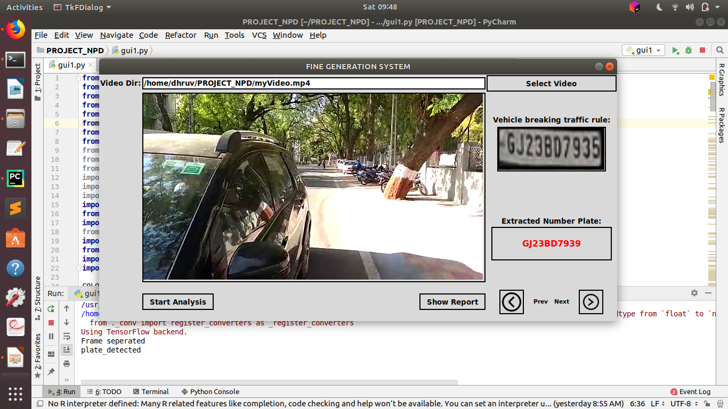

Fig. 6.3 Analysis of a video

System user can generate fine report by pressing “Show Report” button. Figure 6.4 shows the generated report. After pressing “Notify All” button, the e-memo will be sent to the all vehicle owners listed in report. The memo generation process is discussed in upcoming sections (6.2 and 6.3).

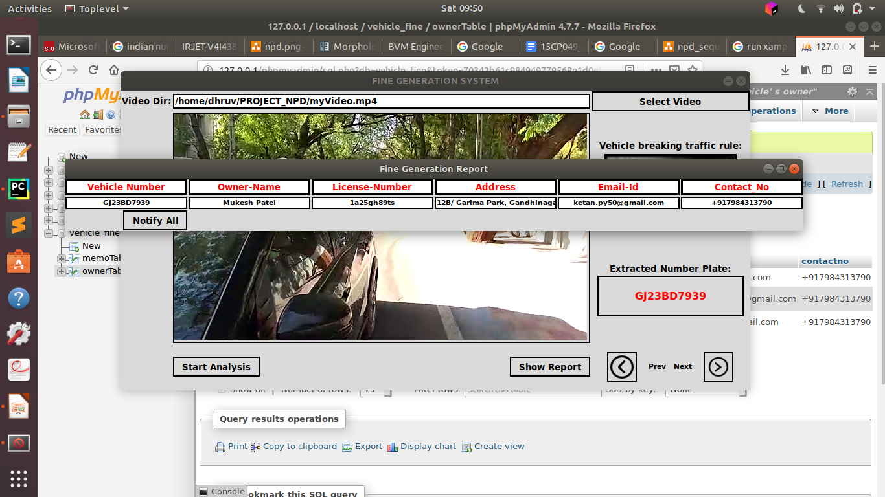

Fig. 6.4 Fine generation report

**6.2 Generating memo through Email**

Email is a common medium for communication today. The documents mailed once to anyone are permanently stored with the Email unless they are explicitly deleted. Thus, one of the means to generate E-memo was decided to be done via Email. Python library for mail generation named SMTP-LIB was utilized in order to generate the required E-memo in form of Email to the designated vehicle’s owner.

The very first step was to obtain the vehicle owner’s Email-Id from the database. Thus, a normalized schema was designed using MySQL in order to efficiently query the database in order to get the user details. The schema goes as follows:

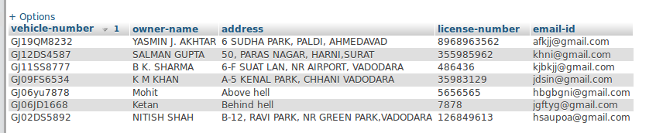

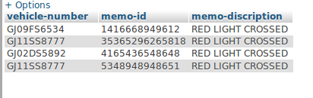

Fig 6.5 Database schema for storing vehicle owner’s details

The python code of SMTP-LIB was stored as an event response block which got executed on the click of a button over the designed GUI. Thus, on click of a button on the designed GUI, the Email will be sent to the vehicle owner who is supposed to pay the fine.

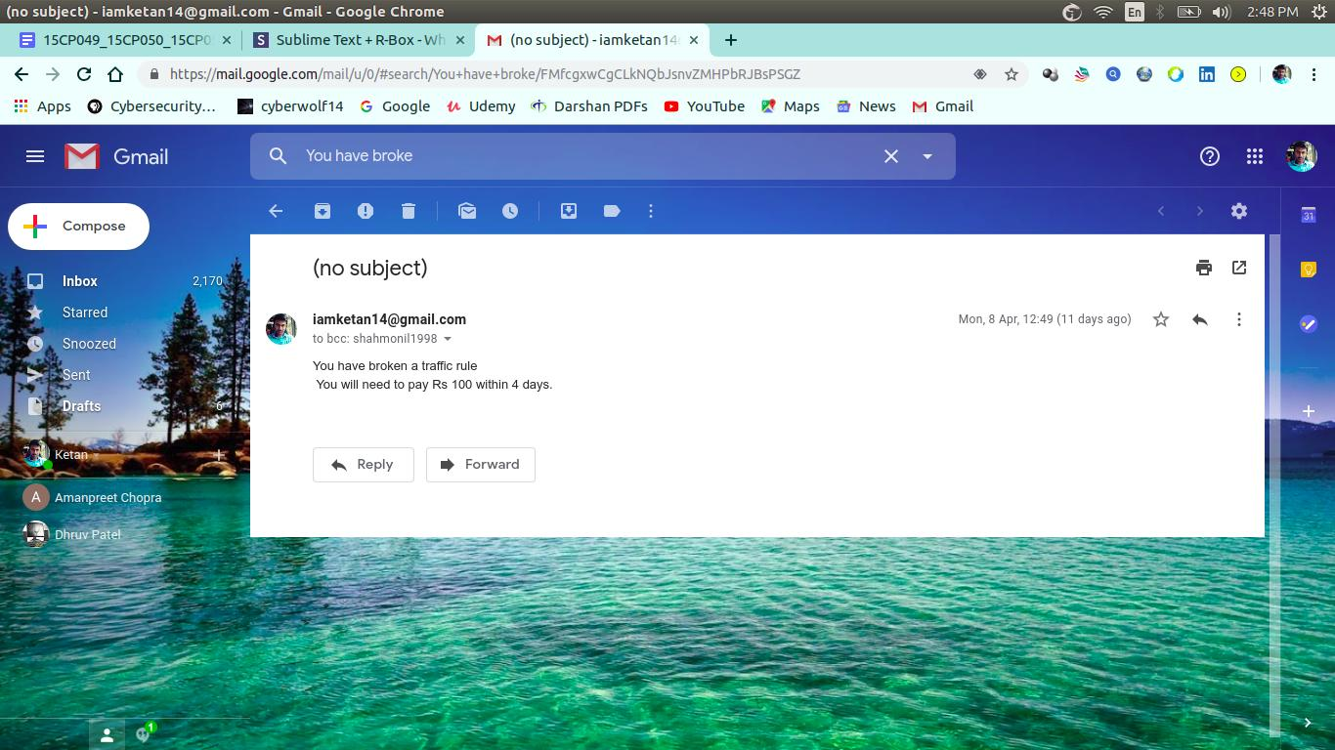

Fig. 6.6 Email Memo

**6.3 Generating memo through Text message:**

After retrieving the contact details of the owner of vehicle who has broken the traffic rule, this system will send the text SMS within time period of 12 hrs to that particular person. There are mainly two methods to send SMS by python. One is to use SinchSMS API for sending messages and another is by using twilio API. We have used latter method.

First, we have to make an account on twilio which is complete tool to send SMS where we must verify the contact details. In trial version, we can only send the message to the contact number which has been verified on twilio website. In the upgrade version, by providing the details of credential information of credit card or debit card we can send SMS to anyone. Furthermore, account_sid and account_token will be provided by twilio for authentication and security purpose. We have implemented for trial version. Twilio will give you a dummy number which sends the SMS from that number.

In a little time owner should see a message which appears on his/her cellular phone. In following figure will give idea how the text message owner of vehicle would have been received. Mainly three things required for communication via simple text SMS.

* The number you are sending the message to
* The twilio contact number that you send the message and message body.

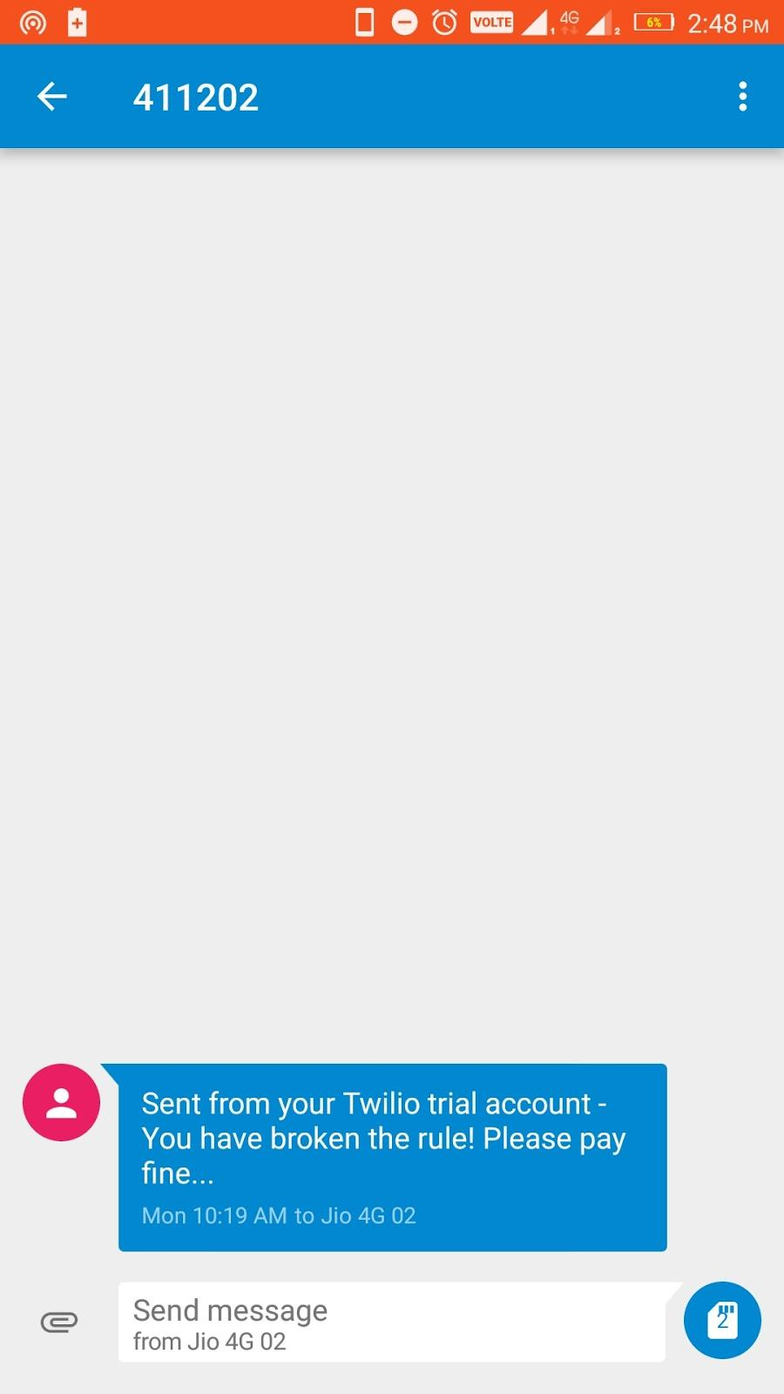

Fig 6.7 Screenshot from mobile where SMS arrived

**CHAPTER-7**

**Conclusions**

**7.1 Conclusions**

After the entire implementation of this project, following conclusions were obtained:

1. The overall quality of video camera used to record the input video must be decent, and if possible sharp in order to efficiently extract the number-plate as well as the number on the number-plate.
2. Image pre-processing plays an important role in getting the required ROI from the image.
3. Various operations like morphological transformations perform better if performed with efficient parameters.
4. Edge detection is an efficient technique in order to detect the number-plate from a car’s image.
5. CNN trained from scratch sometimes gives better accuracy than the CNN obtained from pre-trained transfer learning models.
6. Convolutional Neural Networks are best suited text recognition algorithms in order to get the number on the number-plate. Moreover, the accuracy of CNN highly depends upon its internal parameters and varies with variations in input image’s dimensions.

**7.2 Possible improvements**

Following improvements can be made in order to increase the efficiency of this project:

1. The image processing parameters which are currently static can be obtained through machine learning. Hence, the algorithms will adjust the parameters as per the image brightness, size, contrast and several other properties.
2. The CNN layers can be increased in order to bring the efficiency close to 100% for perfect recognition.
3. The quality of video camera can be improved in order to get better quality videos and hence, sharp images.
4. The entire system can be dumped into an embedded system for real time fine generation.

**References:**

1. Ch. Jaya Lakshmi, DrA.Jhansi Rani, Dr. K. Sri Ramakrishna, M.Lantikiran, V.R. Siddhartha,”A novel Approach for Indian License Plate Recognition System”, IJAEST, Vol 2 Issue I, 2016, pp 010-014
2. Indian Vehicle Number Plate Detection Using Image Processing Swati Bhandari, Prof.Amit Kukreja, Sayali Bhatkar, Jyoti Chavda, Smita Lad International Research Journal of Engineering and Technology (IRJET), Volume: 04 Issue: 04 | Apr -2017
3. Introduction to GUI programming with Tkinter:

<https://python-textbok.readthedocs.io/en/1.0/Introduction_to_GUI_Programming.html>

1. Number plate detection on Indian car vehicles using YOLOv2 <https://medium.com/@ravidesetty/number-plate-detection-on-indian-car-vehicles-using-yo2l2ov2-8c99e1a259f5>
2. Developing a License Plate Recognition System with Machine Learning in Python <https://blog.devcenter.co/developing-a-license-plate-recognition-system-with-machine-learning-in-python-787833569ccd>

# License plate detection with OpenCV and Python <https://cvisiondemy.com/license-plate-detection-with-opencv-and-python/>

1. End-to-End Text Recognition with Convolutional Neural Networks Tao Wang David J. Wu Adam Coates Andrew Y. Ng
2. ImageNet Classification with Deep Convolutional Neural Networks by Alex Krizhevsky Ilya Sutskever Geoffrey E. Hinton University of Toronto
3. Recent Advances in Convolutional Neural Networks by Jiuxiang Gua , Zhenhua Wangb, Jason Kuenb, Lianyang Mab, Amir Shahroudyb, Bing Shuaib, Ting Liub, Xingxing Wangb, Li Wangb, Gang Wangb, Jianfei Caic, Tsuhan Chen